201708161736 process.py : prepare_input_posenet()

View expression:

import matplotlib; matplotlib.pyplot.subplot(1, 2, 1); matplotlib.pyplot.imshow(result[2,:,:,0:3]); matplotlib.pyplot.subplot(1, 2, 2); matplotlib.pyplot.imshow(result[2,:,:,0:4])

(for images #2, which are stacked inside result)

Crops image aroud hot spot with gaussian kernel?

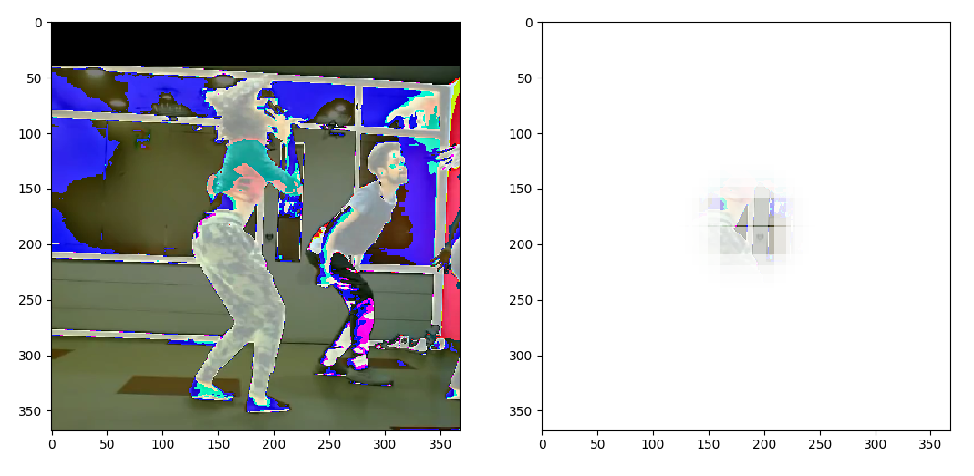
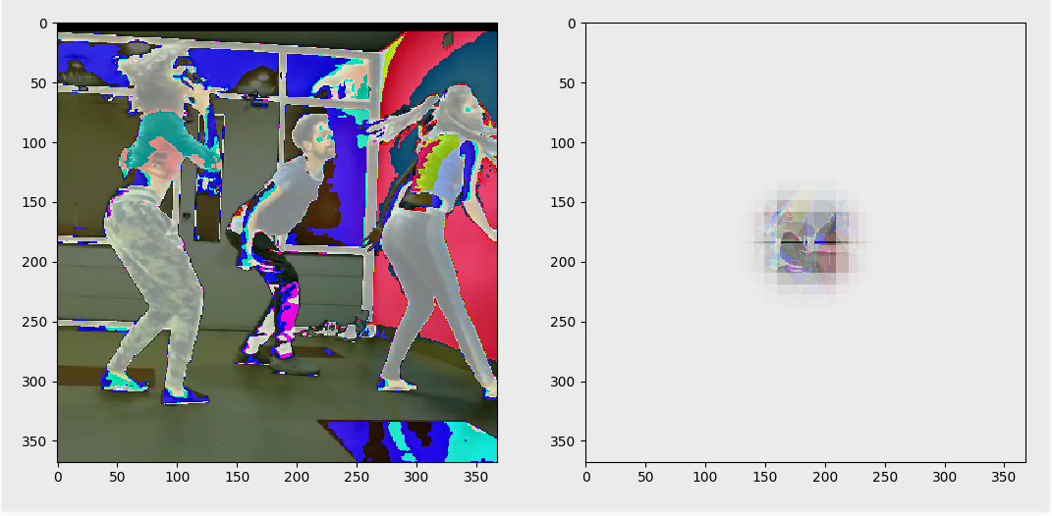

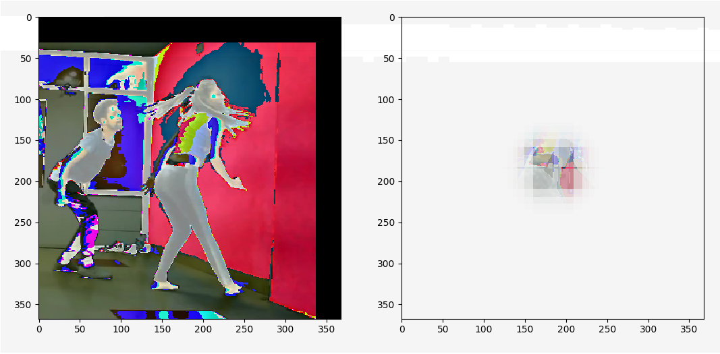

Others are empty

